

SVKM’s NMIMS
Mukesh Patel School of Technology Management & Engineering, Shirpur Campus
Music Website

Faculty mentor: Submitted By:
Dr. MAYANK SOHANI Dhiraj Dhande N209
Manali Naik N215
Sarthak Rathi N216
(Assistant Professor) Course: MBA TECH CE
MPSTME, NMIMS Academic Year:-2024-25
Shirpur Campus

Sr No. | Table Contents | Page No
 | Introduction | 3
 | Architecture Framework | 4
 | Front end designing | 7
 | Backend Designing | 10
 | Implementation Code | 13
 | Results | 22
 | Deployment | 24
 | References | 27

Introduction:

Music has always been an integral part of human expression, bringing people together and enhancing moods through its diverse genres and styles. With the rapid advancement of digital technology, music consumption has shifted from traditional physical formats to online streaming platforms. This project aims to develop a feature-rich Music Website that provides users with an engaging and seamless music experience.

The website will serve as a hub for music lovers, allowing users to explore an extensive collection of songs, create personalized playlists, and enjoy high-quality streaming. It will include advanced features such as genre-based browsing, artist and album search, trending charts, and AI-powered song recommendations to enhance user engagement.

To ensure a smooth experience, the platform will be built using modern web technologies, incorporating a responsive and visually appealing design that adapts to desktops, tablets, and mobile devices. Users will be able to register for personalized accounts, save their favorite tracks, and share playlists with friends, fostering a community-driven musical experience.

Additionally, the project will focus on performance optimization, security, and scalability, ensuring fast load times and a secure environment for users. By implementing an intuitive user interface and efficient backend management, this website will offer a modern, reliable, and enjoyable platform for streaming and discovering music.

Whether for casual listeners or dedicated music enthusiasts, this project aspires to become a go-to destination for exploring and enjoying music in a user-friendly and interactive way.

Architecture Framework:

Frontend (Client-Side) – Overview

The frontend of the music website is responsible for delivering a smooth, interactive, and visually appealing user experience. It handles everything the user interacts with, including navigation, music playback, and playlist management.

Technology Stack

- HTML, CSS, JavaScript – Core web technologies for structuring and styling

- Angular.js – For building a dynamic, component-based UI

Key Features

- User Interface (UI) & Navigation – Intuitive design with a home page, search bar, and music categories

- Music Player – Controls for play, pause, next, previous, and volume adjustment

- User Authentication – Sign up, login, and account management

- Playlist & Favourites – Users can create, edit, and save playlists

- Search & Filters – Song recommendations based on genre, artist, and user preferences

This frontend ensures speed, responsiveness, and a great user experience for music lovers.

Backend (Server-Side) – Overview

The backend of the music website is responsible for handling user authentication, music streaming, playlist management, and data processing. It serves as the bridge between the frontend and the database, ensuring smooth communication and secure transactions.

Technology Stack

- Node.js with Express.js – For handling server-side logic

Key Features
- User Management – Sign up, login, password encryption and role-based access control

- Music Streaming – Delivers audio files efficiently

- Playlist & Favourites Management – Stores and retrieves user-created playlists

- Admin Panel – Allows content management, user moderation, and analytics

This backend architecture ensures high performance, security, and scalability for a seamless music streaming experience.

Database Layer - Overview

The database layer is responsible for storing, managing, and retrieving data efficiently. It handles user data, music metadata, playlists, and streaming history, ensuring fast and reliable access.

Technology Stack

- SQL (MySQL) – For structured data like users, playlists, subscriptions

Key Features
- User Data Storage – Stores user accounts, authentication credentials (hashed passwords), and preferences

- Music Metadata – Information about songs, artists, albums, and genres

- Playlist & Favourites – Tracks user-created playlists and favourite songs

- Streaming History & Recommendations – Stores playback history for AI-based song suggestions

- Analytics & Logs – Keeps track of popular songs, user interactions, and system logs

Front End Designing:

The frontend design of the music website is crucial in delivering an engaging and user-friendly experience. It involves UI/UX principles, responsive design techniques, and modern styling to ensure seamless navigation and interaction.

- 1. Design Principles & UI/UX Approach
A well-designed music website should be:
- Visually appealing – Clean, modern, and aesthetic UI
- User-friendly – Intuitive navigation and easy-to-use controls
- Responsive – Works across devices (desktop, tablet, mobile)
- Fast & Smooth – Optimized for performance and quick loading
- Accessible – Supports keyboard navigation and screen readers

UI Components & Layout

- Header & Navigation Bar
- Contains logo, search bar, menu (Home, Explore, Playlists, Profile)
- Sticky/fixed for easy access while browsing
- Example:

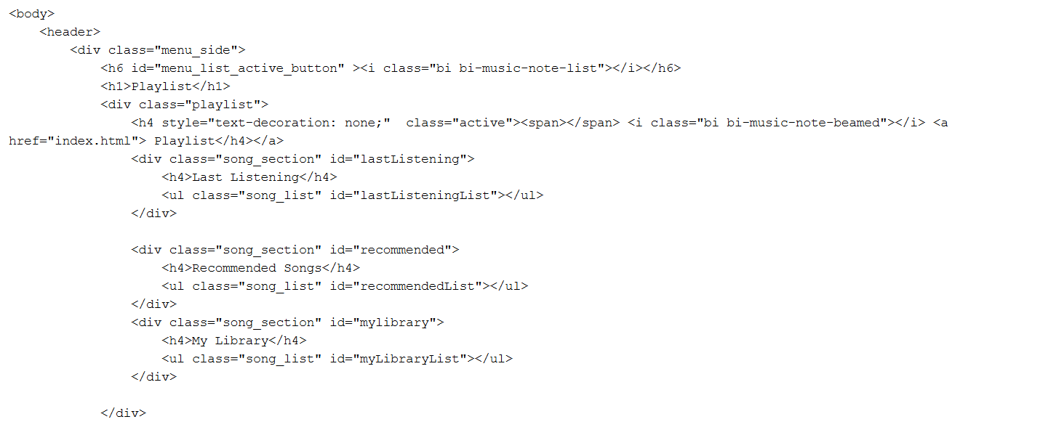

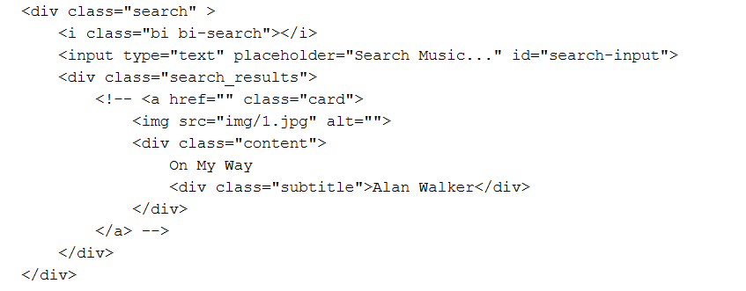

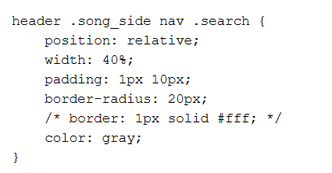

- Homepage Design
- Features hero section with trending songs & artists
- Carousel showcasing new releases & top playlists
- Example layout using CSS for responsiveness

C. Music Player UI
- Contains play, pause, next, previous, volume control, progress bar
- Floating or fixed at the bottom for a persistent listening experience
- Example:

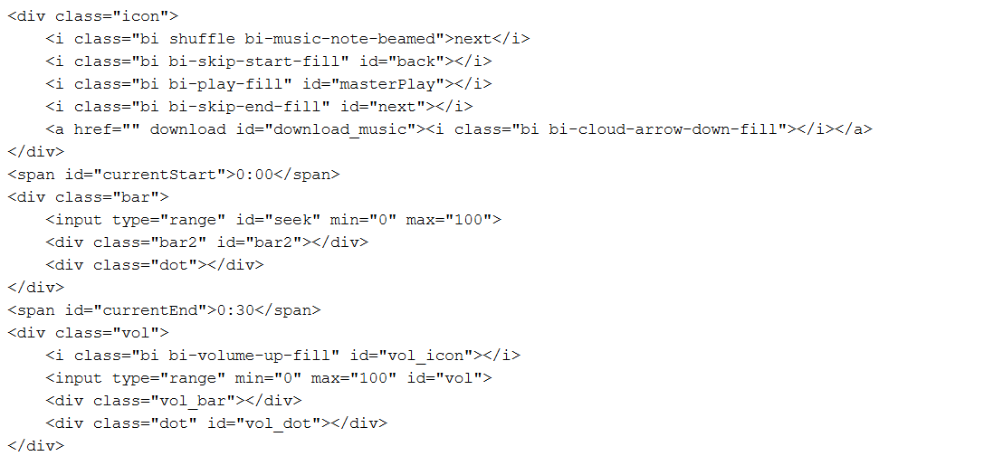

D. Playlist & Favourites Page
- Users can view playlists
- UI with slide along the playlist for song selection.
- Example card design for playlists:

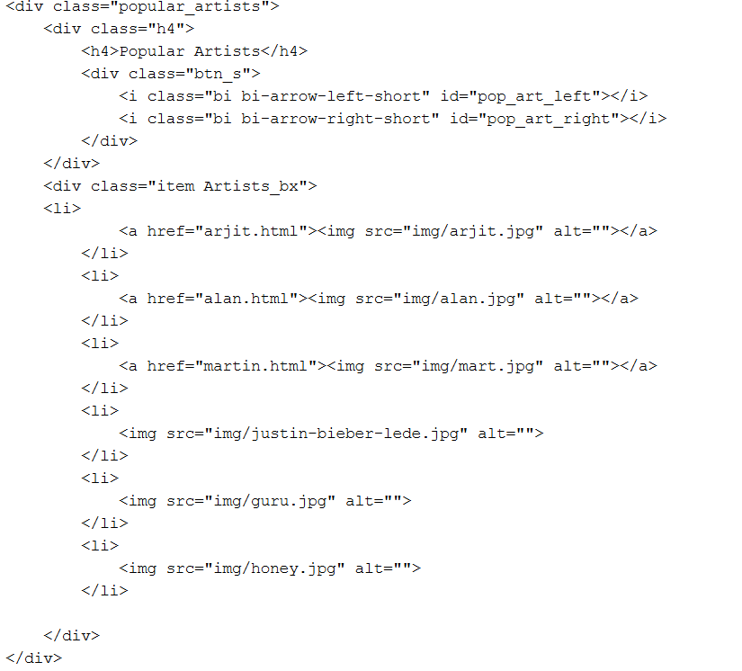

Back End Designing:

require('dotenv').config();
const express = require('express');
const mysql = require('mysql2');
const bcrypt = require('bcryptjs');
const jwt = require('jsonwebtoken');
const cors = require('cors');

const app = express();
app.use(express.json());
app.use(cors());

const db = mysql.createConnection({
host: 'localhost',
user: 'root', // Replace with your MySQL username
password: '', // Replace with your MySQL password
database: 'music_db'
});

db.connect(err => {
if (err) {
console.error('Database connection failed:', err);
return;
}
console.log('Connected to MySQL Database.');
});

// User Registration (Signup)
app.post('/signup', async (req, res) => {
const { fullName, email, password } = req.body;
const hashedPassword = await bcrypt.hash(password, 10);

db.query(
'INSERT INTO users (fullName, email, password) VALUES (?, ?, ?)',
[fullName, email, hashedPassword],
(err, result) => {
if (err) {
if (err.code === 'ER_DUP_ENTRY') return res.status(400).json({ message: 'Email already exists' });
return res.status(500).json({ error: err.message });
}
res.json({ message: 'Signup successful!' });
}
);
});

// User Login
app.post('/login', (req, res) => {
const { email, password } = req.body;

db.query('SELECT * FROM users WHERE email = ?', [email], async (err, results) => {
if (err) return res.status(500).json({ error: err.message });
if (results.length === 0) return res.status(400).json({ message: 'User not found' });

const user = results[0];
const isMatch = await bcrypt.compare(password, user.password);

if (!isMatch) return res.status(401).json({ message: 'Invalid credentials' });

const token = jwt.sign({ userId: user.id, email: user.email }, 'secretkey', { expiresIn: '1h' });

res.json({ message: 'Login successful', token });
});
});

// Start server
const PORT = process.env.PORT || 5000;
app.listen(PORT, () => {
console.log(`Server running on http://localhost:${5000}`);
});

Implementation of Code:

<html>

<head>
<meta charset="UTF-8">
<meta http-equiv="X-UA-Compatible" content="IE=edge">
<meta name="viewport" content="width=device-width, initial-scale=1.0">
<link rel="stylesheet" href="https://cdn.jsdelivr.net/npm/bootstrap-icons@1.8.3/font/bootstrap-icons.css">
<link rel="stylesheet" href="style.css">
<link rel="stylesheet" href="media.css">
<title>Music Website</title>
</head>

<body>
<header>
<div class="menu_side">
<h6 id="menu_list_active_button" ><i class="bi bi-music-note-list"></i></h6>
<h1>Playlist</h1>
<div class="playlist">
<h4 style="text-decoration: none;" class="active"><span></span> <i class="bi bi-music-note-beamed"></i> <a href="index.html"> Playlist</h4></a>
<div class="song_section" id="lastListening">
<h4>Last Listening</h4>
<ul class="song_list" id="lastListeningList"></ul>
</div>

<div class="song_section" id="recommended">
<h4>Recommended Songs</h4>
<ul class="song_list" id="recommendedList"></ul>
</div>
<div class="song_section" id="mylibrary">
<h4>My Library</h4>
<ul class="song_list" id="myLibraryList"></ul>
</div>

</div>
<div class="menu_song">
<li class="songItem">
<span>01</span>
<img src="1.jpg" alt="">
<h5>On My Way <br>
<div class="subtitle">Alan Walker</div>
</h5>
<i class="bi playListPlay bi-play-circle-fill" id="1"></i>
</li>
<li class="songItem">
<span>02</span>
<img src="2.jpeg" alt="">
<h5>On My Way <br>
<div class="subtitle">Alan Walker</div>
</h5>
<i class="bi playListPlay bi-play-circle-fill" id="2"></i>
</li>
<li class="songItem">
<span>03</span>
<img src="3.jpeg" alt="">
<h5>On My Way <br>
<div class="subtitle">Alan Walker</div>
</h5>
<i class="bi playListPlay bi-play-circle-fill" id="3"></i>
</li>
<li class="songItem">
<span>04</span>
<img src="4.jpeg" alt="">
<h5>On My Way <br>
<div class="subtitle">Alan Walker</div>
</h5>
<i class="bi playListPlay bi-play-circle-fill" id="4"></i>
</li>
<li class="songItem">
<span>05</span>
<img src="5.jpeg" alt="">
<h5>On My Way <br>
<div class="subtitle">Alan Walker</div>
</h5>
<i class="bi playListPlay bi-play-circle-fill" id="5"></i>
</li>
<li class="songItem">
<span>06</span>
<img src="6.jpeg" alt="">
<h5>On My Way <br>
<div class="subtitle">Alan Walker</div>
</h5>
<i class="bi playListPlay bi-play-circle-fill" id="6"></i>
</li>
<li class="songItem">
<span>07</span>
<img src="7.jpeg" alt="">
<h5>On My Way <br>
<div class="subtitle">Alan Walker</div>
</h5>
<i class="bi playListPlay bi-play-circle-fill" id="7"></i>
</li>

</div>
</div>
<div class="song_side">
<nav>
<ul>
<li>Discover <span></span></li>

<li>RADIO</li>
</ul>
<div class="search" >
<i class="bi bi-search"></i>
<input type="text" placeholder="Search Music..." id="search-input">
<div class="search_results">
<!-- <a href="" class="card">
<img src="img/1.jpg" alt="">
<div class="content">
On My Way
<div class="subtitle">Alan Walker</div>
</div>
</a> -->
</div>
</div>
<div class="user">
<a href="auth.html"><img src="imglogin.jpg" ></a>
</div>
</nav>
<div class="content" id="currentSongDetails">
<img id="currentSongImage" src="img/1.jpeg" alt="Current Song Image" width="100px">
<h1>Now Playing: <span id="currentSongTitle">Select a Song</span></h1>
<p id="currentSongArtist">Choose a song to play</p>
</div>

<div class="popular_song">
<div class="h4">
<h4>Popular Song</h4>
<div class="btn_s">
<i class="bi bi-arrow-left-short" id="pop_song_left"></i>
<i class="bi bi-arrow-right-short" id="pop_song_right"></i>
</div>
</div>
<div class="pop_song">
<li class="songItem">
<div class="img_play">
<img src="img/2.jpg" alt="">
<i class="bi playListPlay bi-play-circle-fill" id="8"></i>
</div>
<h5>On My Way<br>
<div class="subtitle">Alan Walker</div>
</h5>
</li>
<li class="songItem">
<div class="img_play">
<img src="img/2.jpg" alt="">
<i class="bi playListPlay bi-play-circle-fill" id="9"></i>
</div>
<h5>On My Way<br>
<div class="subtitle">Alan Walker</div>
</h5>
</li>
<li class="songItem">
<div class="img_play">
<img src="img/2.jpg" alt="">
<i class="bi playListPlay bi-play-circle-fill" id="10"></i>
</div>
<h5>On My Way<br>
<div class="subtitle">Alan Walker</div>
</h5>
</li>
<li class="songItem">
<div class="img_play">
<img src="img/2.jpg" alt="">
<i class="bi playListPlay bi-play-circle-fill" id="11"></i>
</div>
<h5>On My Way<br>
<div class="subtitle">Alan Walker</div>
</h5>
</li>
<li class="songItem">
<div class="img_play">
<img src="img/2.jpg" alt="">
<i class="bi playListPlay bi-play-circle-fill" id="12"></i>
</div>
<h5>On My Way<br>
<div class="subtitle">Alan Walker</div>
</h5>
</li>
<li class="songItem">
<div class="img_play">
<img src="img/2.jpg" alt="">
<i class="bi playListPlay bi-play-circle-fill" id="13"></i>
</div>
<h5>On My Way<br>
<div class="subtitle">Alan Walker</div>
</h5>
</li>
<li class="songItem">
<div class="img_play">
<img src="img/2.jpg" alt="">
<i class="bi playListPlay bi-play-circle-fill" id="14"></i>
</div>
<h5>On My Way<br>
<div class="subtitle">Alan Walker</div>
</h5>
</li>
<li class="songItem">
<div class="img_play">
<img src="img/2.jpg" alt="">
<i class="bi playListPlay bi-play-circle-fill" id="15"></i>
</div>
<h5>On My Way<br>
<div class="subtitle">Alan Walker</div>
</h5>
</li>
<li class="songItem">
<div class="img_play">
<img src="img/2.jpg" alt="">
<i class="bi playListPlay bi-play-circle-fill" id="16"></i>
</div>
<h5>On My Way<br>
<div class="subtitle">Alan Walker</div>
</h5>
</li>
<li class="songItem">
<div class="img_play">
<img src="img/2.jpg" alt="">
<i class="bi playListPlay bi-play-circle-fill" id="17"></i>
</div>
<h5>On My Way<br>
<div class="subtitle">Alan Walker</div>
</h5>
</li>
<li class="songItem">
<div class="img_play">
<img src="img/2.jpg" alt="">
<i class="bi playListPlay bi-play-circle-fill" id="18"></i>
</div>
<h5>On My Way<br>
<div class="subtitle">Alan Walker</div>
</h5>
</li>
<li class="songItem">
<div class="img_play">
<img src="img/2.jpg" alt="">
<i class="bi playListPlay bi-play-circle-fill" id="19"></i>
</div>
<h5>On My Way<br>
<div class="subtitle">Alan Walker</div>
</h5>
</li>
<li class="songItem">
<div class="img_play">
<img src="img/20.jpg" alt="">
<i class="bi playListPlay bi-play-circle-fill" id="20"></i>
</div>
<h5>On My Way<br>
<div class="subtitle">Alan Walker</div>
</h5>
</li>
</div>
</div>
<div class="popular_artists">
<div class="h4">
<h4>Popular Artists</h4>
<div class="btn_s">
<i class="bi bi-arrow-left-short" id="pop_art_left"></i>
<i class="bi bi-arrow-right-short" id="pop_art_right"></i>
</div>
</div>
<div class="item Artists_bx">
<li>
<a href="arjit.html"><img src="img/arjit.jpg" alt=""></a>
</li>
<li>
<a href="alan.html"><img src="img/alan.jpg" alt=""></a>
</li>
<li>
<a href="martin.html"><img src="img/mart.jpg" alt=""></a>
</li>
<li>
<img src="img/justin-bieber-lede.jpg" alt="">
</li>
<li>
<img src="img/guru.jpg" alt="">
</li>
<li>
<img src="img/honey.jpg" alt="">
</li>

</div>
</div>
</div>
<div class="master_play">
<div class="wave" id="wave">
<div class="wave1"></div>
<div class="wave1"></div>
<div class="wave1"></div>
</div>
<img src="img/20.jpeg" alt="" id="poster_master_play">
<h5 id="title"> Jab Koi Baat <div class="subtitle">Bankim Chandra</div>
</h5>
<div class="icon">
<i class="bi shuffle bi-music-note-beamed">next</i>
<i class="bi bi-skip-start-fill" id="back"></i>
<i class="bi bi-play-fill" id="masterPlay"></i>
<i class="bi bi-skip-end-fill" id="next"></i>
<a href="" download id="download_music"><i class="bi bi-cloud-arrow-down-fill"></i></a>
</div>
<span id="currentStart">0:00</span>
<div class="bar">
<input type="range" id="seek" min="0" max="100">
<div class="bar2" id="bar2"></div>
<div class="dot"></div>
</div>
<span id="currentEnd">0:30</span>
<div class="vol">
<i class="bi bi-volume-up-fill" id="vol_icon"></i>
<input type="range" min="0" max="100" id="vol">
<div class="vol_bar"></div>
<div class="dot" id="vol_dot"></div>
</div>
</div>
</header>
<script src="app.js"></script>
<script>
let menu_list_active_button = document.getElementById('menu_list_active_button');
let menu_side = document.getElementsByClassName('menu_side')[0];

let song_side = document.getElementsByClassName('song_side')[0];

let xm = window.matchMedia("(max-width: 900px)");

menu_list_active_button.addEventListener('click', () => {
if (xm.matches) {
menu_side.style.transform = "unset";
menu_list_active_button.style.opacity = 0;
}
})

song_side.addEventListener('click', () => {
if (xm.matches) {
menu_side.style.transform = "translateX(-100%)";
menu_list_active_button.style.opacity = 1;
}
})
</script>
<!-- Search Results Modal -->
<div id="searchModal" class="modal">
<div class="modal-content">
<span class="close">&times;</span>
<h2>Search Results</h2>
<div class="search_results_modal"></div>
</div>
</div>
</body>

</html>

Results:

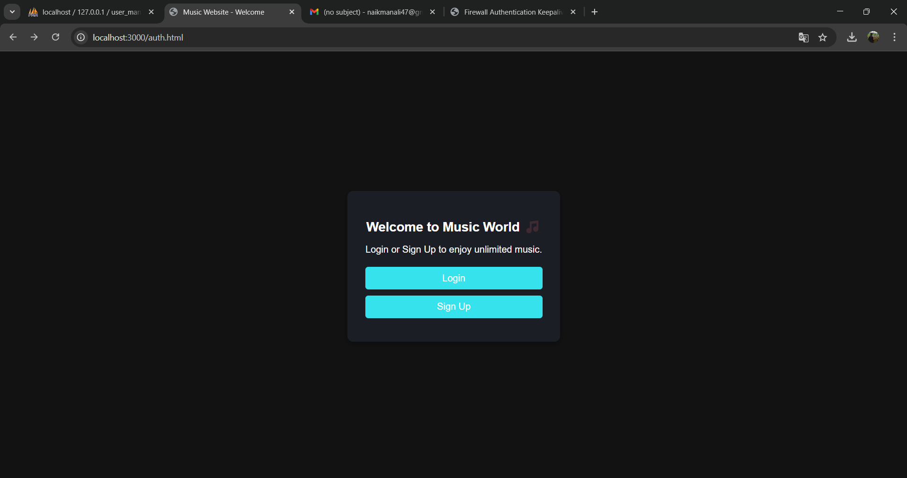

Login page:

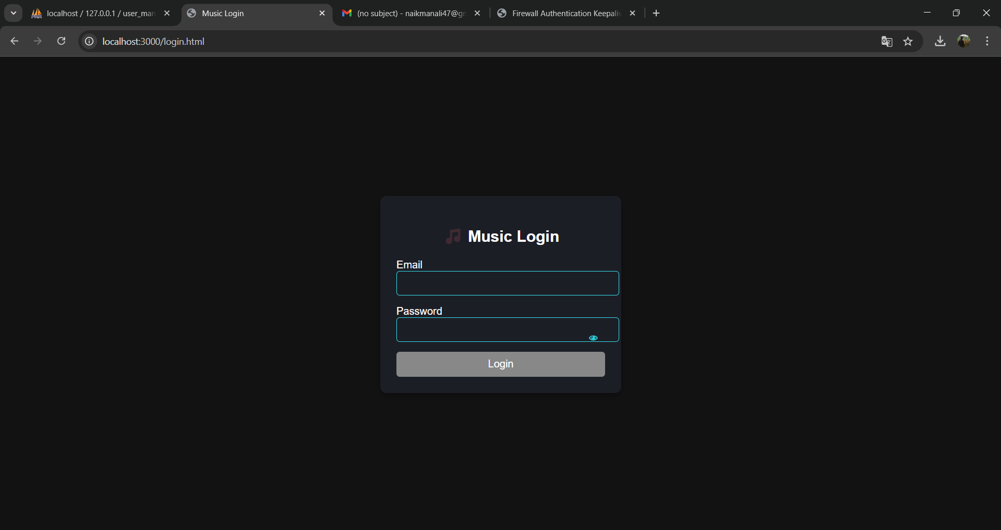

Sign up

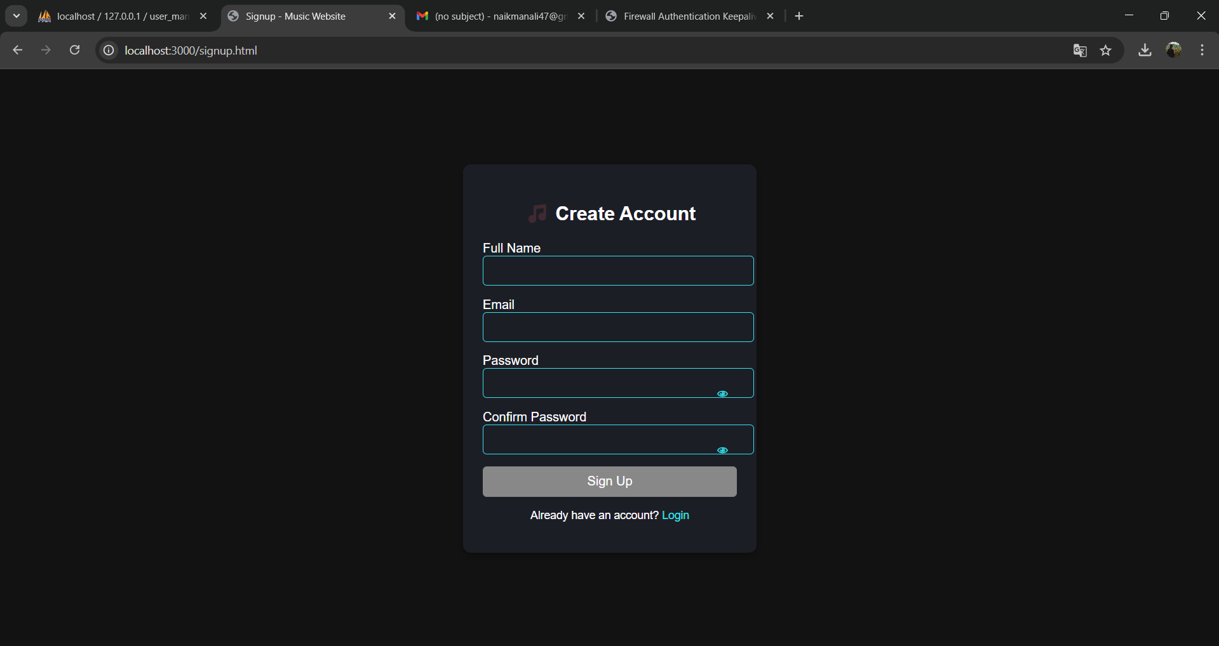

Home Page:

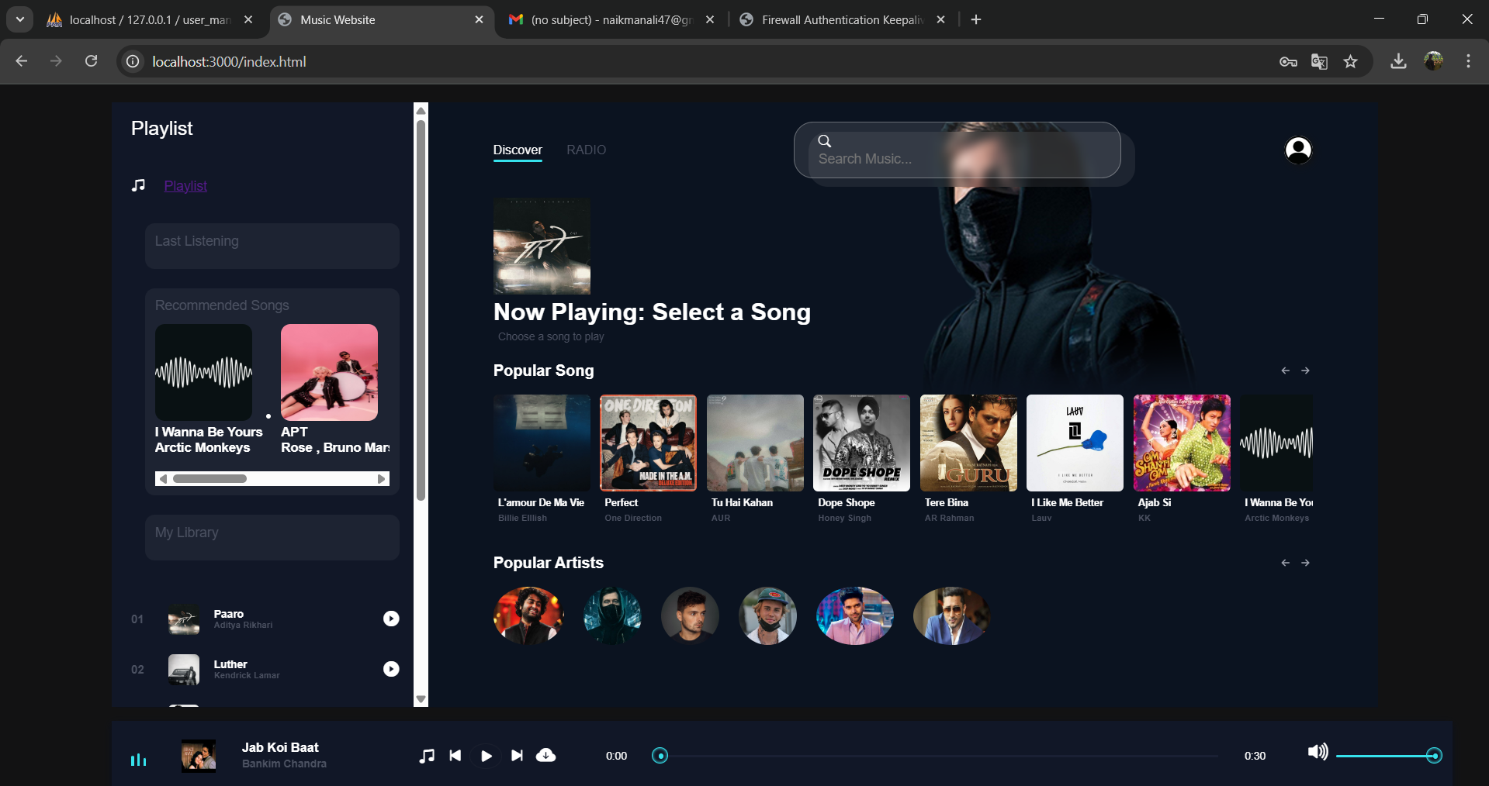

Artist’s page:

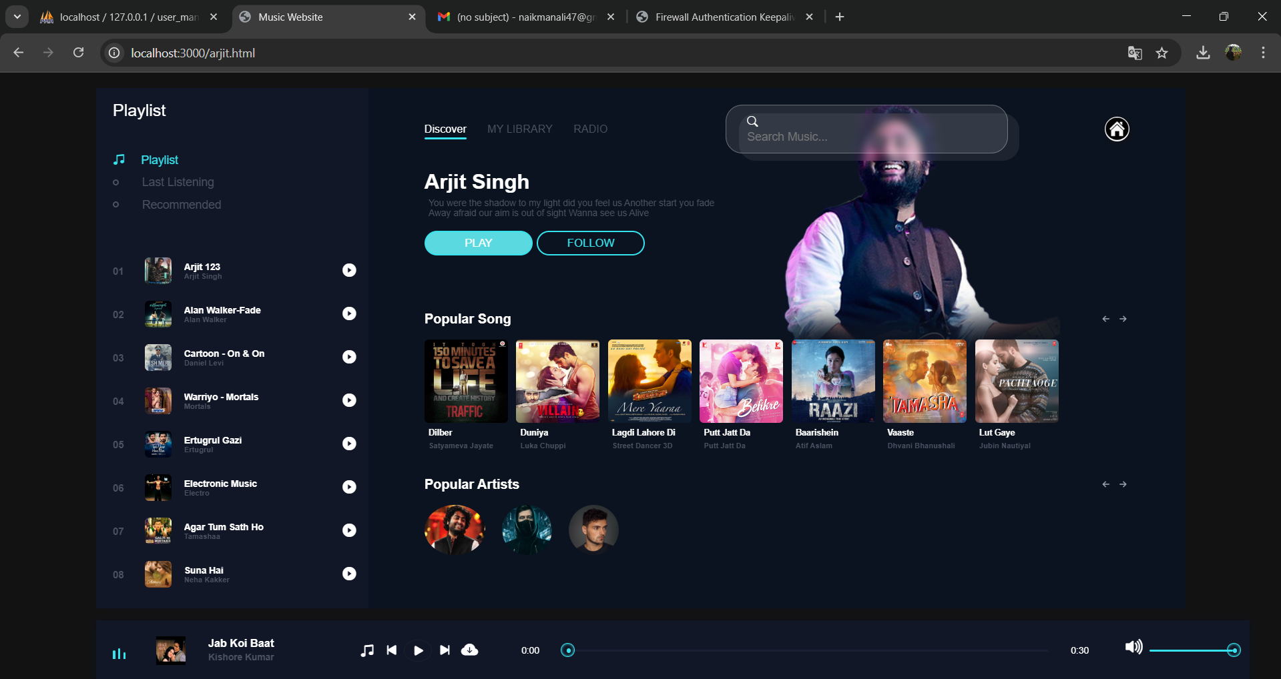

Deployment:

The music website has been successfully deployed and is live at: http://localhost:3000/index.html

Deployment Platform: Visual Studio

Steps for Deployment:
- The project was pushed to Visual Studio for version control and collaboration.
- The Visual Studio was connected to the deployment platform.
- The platform automatically builds and deploys the project from the main branch.
- Any changes pushed to the branch trigger a new build and update the live website automatically.

Technologies Used:
- Frontend: HTML, CSS and JavaScript
- Backend: Node.js
- Hosting: localhost:3000

References:

- https://www.google.co.in/Google.com
- https://www.youtube.com/

